Report:

A Social Relationships Based Service Recommendation System for SIoT Devices

Written and presented by: 欧马(B20170619) , 本萨德 (B20170616), 纳萨尔 (B20180657)

# Abstract

Social Internet of Things comes as a new paradigm of Internet of Things to solve the problems of network discovery, navigability and service composition. It aims to socialize the IoT devices and shape the interconnection between them into social interaction just like human beings. In IoT scenarios, a device can offer multiple services and different devices can offer the same services with different parameters and interest factors. The proliferation of offered services led to difficulties during service filtering and customization, this problem is known as services explosion. The selection of a suitable service that fits the requirements of the applications and devices is a challenging task. Several works have addressed service discovery, composition and selection in IoT. However, these works did not emphasize on the fact that incorporating the users’ social features can increase the efficiency of the recommended services and help us to offer context-aware services. In this paper, we present a service recommendation system that takes advantage of the social relationships between devices’ owners, where the recommendation is based on the different relationships between the service requester and service provider. Experimental results show, in the context of IoT, that incorporating the users’ social relationships in service recommendation increases the accuracy and diversity of the offered services.

# I. Introduction

The Internet of Things or IoT is a network of interconnected heterogeneous devices, objects, and machines that are uniquely identifiable which provide data transferability without the need for human-to-computer or human-to-human interaction. Based on the recent statistics released by Gartner [1] shows that the number of connected devices in use in 2019 is 14.2 billion, and this number is expected to increase to 25 billion by 2025. IoT devices became a vital part of our daily lives. The applications of IoT have expanded to many areas such as consumer, commercial and industrial domains [2]. With this expansion, IoT applications in the consumer side have effectively settled on smart home, smart health care, and wearable devices scenarios. However, the IoT is foreseen to be more scaling in which the needs of network navigability become more crucial. The IoT devices will consume and use services among each other, which cause the navigability to be limited and the selection and searching of suitable service will be a major challenge [3]. Services composition and discovery depends to the network navigability, which is considered a major issue when the network is composed of billions of connected devices. Establishing extensive social relationships among devices will effectively enhance the lookup service and resources discovery [4]. Social network of intelligent objects, known by Social Internet of things, is a mapping between social network of humans and cyberspace [5]. This mapping architecture mainly resolves the IoT future problems that are related to service discovery and composition, based on the users’ trustworthiness by maintaining social relationships between objects and allowing devices to interact just as human beings do. In SIoT, objects have the ability to interact and behave in a social manner. They request and provide services in a reliable and efficient way, sharing resources and services. The social structure of SIoT is inspired by Fiske’s theory [6] which presents the social relationships between humans. Fiske studied the nature of human relationships and established a relational model of social interactions. This model describes four types of relationships between individuals: Equality matching relationships, authority ranking relationships, market-pricing relationships and communal sharing relationships. This model can be mapped to objects’ relationships in terms of communication between objects, sharing resources, authority classification of objects and mutual benefits of collaboration between devices. Based on the aforementioned model, some works [7] proposed objects relationships classification which describes how devices are connected to each other. In the SIoT environment, each device can act as a service/information provider as well as requester. The huge number of exchanged services between devices represents a challenge for choosing the suitable services where the need for service recommendation systems appeared. In the other hand, social relationships between humans gained a great interest of researchers to build sophisticated recommendation systems that put in use the trust within the same social circle. People tend to share resources with their social circle members and could rely on the received recommendation from persons they trust, especially if they share the same interests [8]. Different studies regarding the recommendation system of social network trust were conducted based on this latter theory [9] [10][11]. However, these works apply the service recommendation on non-classified social circles of users as they are considered the major

target for recommendation. In our approach, we use the social relationships defined in the SIoT to establish service recommendations between devices and enhance the service discovery and composition. The main contributions of the presented work in this article are as follows: 1) We proposed a SIoT based service recommendation framework, where the devices inherit the social relationship of their owners to offer a social-aware service recommendation. 2) We proposed a boundary based community detection algorithm that we used to form socially-connected device communities. 3) We present three user case scenarios in which our service recommendation approach can be used as a part of SIoT environment. 4) We prove the efficiency of the proposed system by comparing it to previous similar works using extensive experiment on real world dataset that was collected from Santander smart city. The rest of this paper is organized as follows: Section II introduces the related works of the different service recommendation approaches and applications in IoT environment. The proposed framework overview is depicted in Section III. In Section IV, we introduce three motivating examples that emphasize the importance of using social relationships for service recommendation in SIoT. Section V presents the proposed recommendation architecture that use the different devices relationships to offer service recommendations. Moreover, a formal modelling of different SIoT elements to maintain the service recommendations is explained at the end of this section. Section VI describes the experiment dataset used to test the performance of the proposed framework, the evaluation metrics and the baselines. The results and discussion are presented in Section VII. Finally, In Section VIII, we conclude the paper and present our future research directions.

# II. The framework overview

The architecture of the proposed framework is presented in Fig.1. The framework consists of three parts: devices, users and services. The links shown in the framework present the interactions between devices that are owned by different users in SIoT. In other words, the relationships between users can be passed to devices. The framework can be modelled as a social graph composed out of social relationships and recommendation interactions. The interactions include the exchange of services between devices in term of data exchanging and processing. For example, a specific service offered by a device will be recommended to other devices that have tight social relationships with the source device. These groups are called socially-connected device communities. Such communities are composed out of devices belonging to the same group of friends, brand, location, or has frequent social interactions. The relationships considered in the proposed framework including but not limited to location based relationships, ownership based relationship and friendship-based relationships. Since the similarity and trustworthiness are increased in a group of friends/devices due to the social relationships between devices, these groups can be used to apply personalized hybrid service recommendations in the SIoT environment. Therefore, both service discovery and composition of SIoT would be improved by offering socially-aware services recommendations. After forming the socially-connected device communities, the framework analyses the interests of the owners to form a clusters of users that have common interests and their devices are within the same socially-connected cluster, hence the framework can recommend interest oriented services. These groups are known as groups of interest. In the next sections, we will explain each part of the proposed framework in details, starting by the creation of relationships between devices in the SIoT, managing groups of interests and applying the recommendation and evaluation of the results.

Fig.1: Architecture model of SIoT service recommendation system

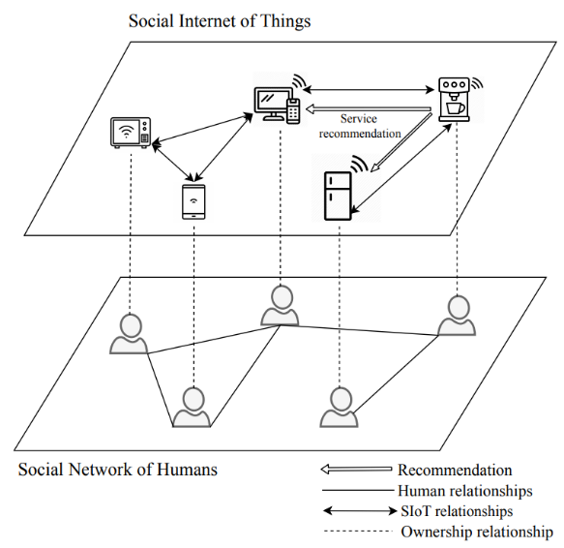

# III. Motivating example

SIoT computing paradigm improves the network navigability and service composition, by making the devices interact in a social way. The different aforementioned SIoT relationships define the scenarios where the social interaction between devices can be used. In order to improve the service selection and composition, devices can interact and match services’ providers and requesters. Moreover, they can collaborate to provide customization, configuration and relevant service exchange between each other based on trust, accuracy and precision. Collaborative recommendation approaches are of a great interest to enhance service composition and provide a high performance service matching and selections. For the purpose of this study, we only present three types of SIoT relationships in the following example. These relationships are: co-location relationship (CLOR), co-work relationship (CWOR), and parental object relationships (POR), as shown in Fig.2:

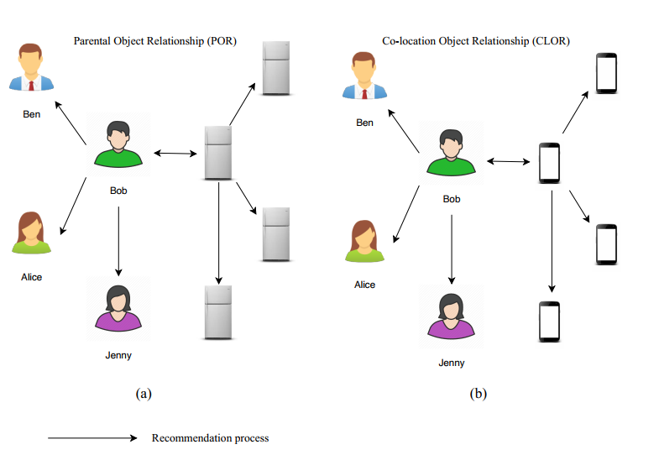

1) Bob and Ben went to the museum. They both do not have much time to explore all the art pieces. Their phones maintain location based relationships with the other people’s phones at the same place. Once they grant this relationship preference to their devices, nearby devices generate recommendations to the newcomers. These recommendations include statistics about the most visited spots, the spent time in front of each piece of art; Hence, people’s interests. Some rules can be applied to generate the recommendations such as the common interests of the devices’ owners, the distance and the recommendation relevance factor. Devices can be clustered into a socially connected communities to manage these recommendations. Devices with location-based relationships can detect, receive and offer recommendations to enhance the quality of service discovery.

2) Consider a group of 4 friends: Bob, Ben, Jenny and Alice. They all have smart fridges; these fridges maintain friend based social relationships. Bob buys the same food frequently which implies he likes it. However, the first time he bought it and put it in the fridge, he read the food preservation instructions carefully to configure the temperature degree. The fridge records Bob’s food preservation preferences and habits and recommend it to the other fridges of Ben, Jenny and Alice. In general, devices owned by a group of friends can recommend artefacts (services, applications, data, settings ...etc.) based on the habits and interest of the group members.

3) In a work place, a new public printer is installed. Between this new printer and the other devices, two relationships can be maintained: location based and work based relationships. The other devices can recommend preferences, driver software and settings like protocols of communication and so on.

# IV. System design and problem formulation

To maintain the proposed recommendation system, we classified the IoT devices and users into groups of interests based on their social relationships, interests and preferences. These properties and interests are defined based on the type of relationships between devices. The creation of group of interests passes by two steps. The first step aims to create socially-connected device community; while in the second step, we subdivide these device communities into final groups of interests. The social graph in SIoT is considered as a mapping of users’ social relationships to devices relationships. In other words, the mapping of social network of human to the cyberspace [?], [?]. This solves the problems of service discovery and resolution and put in use the benefits of social relationships between devices. After the creation of these groups, the recommendation process is applied between devices taking in consideration the permission of their users. In the next subsections, we will discuss the SIoT relationship modelling and explain the device community detect and the creation of groups of interests in details. Later on, we will discuss the process of recommendation between devices at the same group.

## A. SIoT relationships formal modelling

The groups of users’ interest are created over the socially-connected device communities. These group of interest and socially-connected devices define the interaction between users and devices in a social manner. The services in the other hand, are described as the input/output of this ecosystem. The different parts of the proposed framework are explained in Fig. 1 where three major parts can be presented as users, devices, and services. the devices being owned by users are implicated in the social interactions between the latter, this means that the social interactions in the user’s level are pass down to the devices level and create SIoT relationships. Therefore, devices can perform different tasks and interact in a social way after the decision of users, which results a social-aware services exchanges and composition. We can model the different system actors as below:

Let be the set of all users, and denotes the set of all devices in the network, and let denotes the set of services offered by these devices. Each device is owned by one user. We denote the set of devices owned by a user as . Similarly, each device offers one or more services; we denote the set of offered services by device as . To model the social relationship that holds among the users and consequently between their devices, we consider the following relationships: (1) Co-location Object Relationship (CLOR), which indicates that the two objects are presented simultaneously at the same place such as wearable devices or smart home devices. (2) Co-work Object Relationship (CWOR): indicates that the two objects are cooperating in the same application or doing the same task, processing to achieve a collective goal. (3) Parental Object Relationship (POR): indicates that the two objects are owned by the same family members or friends. (4) Ownership Object Relationship (OOR): indicates that the two objects belong to the same owner. (Devices worn or owned by the same person). (5) Social Object Relationship (SOR): indicates that the two objects have intermittent interactions when social connection happens between their owners. Formally, let represent the binary set of social relationships between two devices.

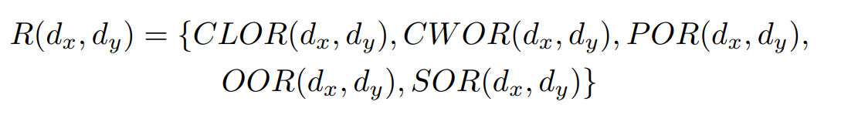

gets the value 1 if there is a relationship, otherwise it gets the value 0. For example, indicates that the devices d1 and d3 are present in the same location and belong to the same owner. In addition to the social relationships between users that we use to classify the devices into socially-connected device communities, we cluster the users who own these devices according to their common interests, subsequently offering them interest based services. Formally, let represents the set of interests of user ux. We have used Jaccard similarity coefficient to measure the similarity between users, as shown in (1). To measure the similarity between two devices (SimD), we compute the interest similarity between their owners (SimU), and their social connectivity similarity, as shown in (2)

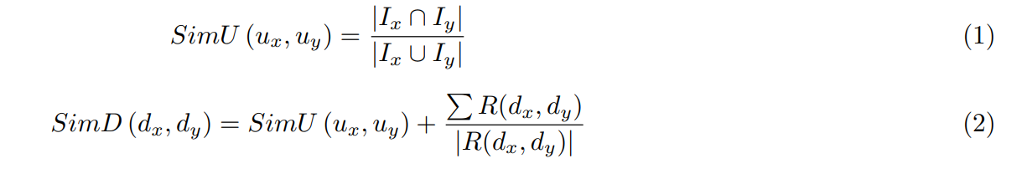

## B. Socially-connected device communities

As mentioned earlier, the SIoT devices are divided into communities based on the connectivity degree of their social relationships. Firstly, our approach computes the device communities of each social relationship separately, after that, we determine the socially-connected device communities by finding merging the communities of individual social relationships. An example of a socially-connected device community of three social relationships is shown in Fig.3. To classify the devices into communities based on their social relationships, our approach identifies the boundaries that divide the device network into communities. The logic behind our approach is that nodes at the community boundaries usually are more connected to the inbound community nodes more than nodes outside the current community. For example, in Fig.4 the community boundary is denoted by the dashed line, and the orange nodes are classified outside the current community because their inbound connectivity degree is less than their external connectivity. The steps of computing the individual communities of each social relationship is presented in Algorithm 1. The set ω is used to maintain a list of the previously visited nodes to avoid infinite looping, N is the set of current studied boundaries, and C is the set of current community nodes. We first determine the community head node, which is the node the have the maximum connectivity degree in the current type of social relationship (). After that the community is extended by recursively including the list of neighbour nodes (and subsequently their neighbour nodes and so on) that their inner connectivity with the current community is greater than its external connectivity (lines 9-12). An example of the iteration runs of Algorithm 1 is shown in Fig.4, the CH node denote the community head node, the green nodes represent the immediate neighbours of the community head that have been added in the first round, the blue nodes represent two hop away neighbours that have been added in the second round, and the orange nodes denote the neighbour nodes that have been excluded as their external connectivity is greater than the inner connectivity with the current community.

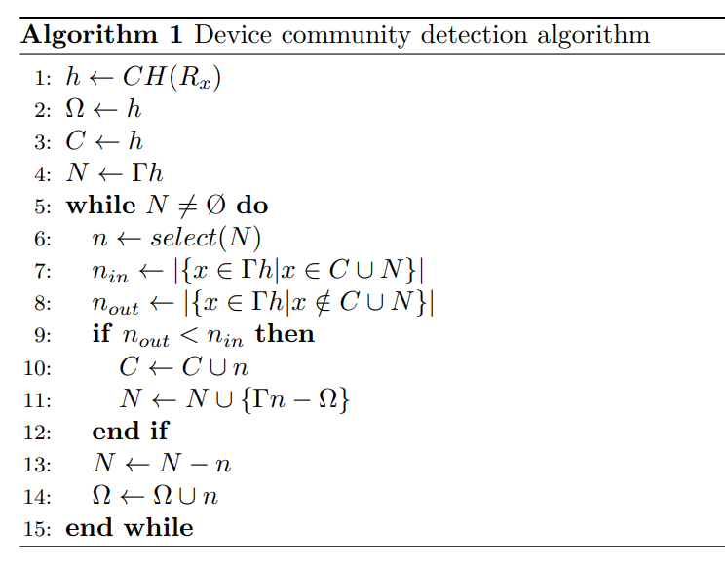

|  |  |
| --- | --- |
| C:\Users\Abdelkarim\AppData\Local\Microsoft\Windows\INetCache\Content.Word\communities_fusion.png  Fig. 3: Socially-connected devices community’s fusion | C:\Users\Abdelkarim\AppData\Local\Microsoft\Windows\INetCache\Content.Word\community.png  Fig. 4: Device community’s detection |

## C. Service recommendation process

After finding the socially-connected device communities, the proposed framework finds the set of users within the same community that have common interests, which is known as group of interest, as shown in Fig.5. The logic behind finding the groups of interest is that the services offered by a given user is more relevant to users with the similar interests, and the logic behind finding these groups of interest within the same socially-connected device community is to allow more flexible service recommendations that is because devices within the same socially-connected community are probably in the same location and other common social relationships. The combination of socially-connected device communities with the group of interest can make the recommended services not only social-aware, but also customized based on the common interest of the users, as shown in Fig.6. Since the similarity and trustworthiness are increased in a group of friends/devices due to the social relationship between devices, these groups can be used to apply personalized recommendations in SIoT. To select the most suitable services of a given user, we used hybrid filtering approach [?], since collaborative filtering helps to select the neighbours (users with similar interests), and content filtering is used to select the most socially connected devices (devices with strong social connection with the user’s devices). Formally, let be a device that belongs to the user . searches for the service . The challenge here is to recommend the service that belongs to the user, the most socially connected to the user . The recommended services set is computed as shown in (3), where is the recommended service, and uy is the owner of the recommended service.

|  |  |
| --- | --- |
| Fig. 5: Groups of interests | Fig. 6: Groups of interest with socially-connected device communities |



# V. Experiment and evaluation

To evaluate the effectiveness of the proposed framework, we have conducted the experiment on two different datasets. The first dataset contains information about devices and the social relationships that connect them to form the SIoT graph, and we have used this dataset to prove the effectiveness of using socially-connected devices community to enhance the service recommendation process. While the second dataset contains information about the users and their interests, and the object of testing using this dataset is to prove the importance of determining the groups of interest within the same socially-connected device community to offer interest-aware service recommendations.

## A. SIoT devices dataset

We have constructed this dataset in one of our previous works [?] and made it publicly available. The dataset contains information about devices based on real IoT objects located in the smart city of Santander and classified following the typologies and data model for objects.

1) Objects description: The dataset contains a total of 16216 devices, of which 14600 are objects from private users and 1616 are objects from public services. Every object in the dataset is described in the following format:

* *id\_device*: The identifier of the device.
* *id\_user*: The identifier of the device owner.
* *device\_type*: Category associated to the device.
* *device\_brand*: Device’s brand.
* *device\_model*: Device’s model.

For every object category (device type), the profile defines the set of possible services offered by each category as well as the possible applications that every object category is interested in.

* *device\_type*: Category associated to the device.
* *id\_of\_service*: List of offered service identifiers.
* *id\_req\_application*: List of application ID.

The type of private (users) devices are: smartphones, cars, tablets, smartwatch, PC, printers and home sensors. The types of public city devices are described in Table I.

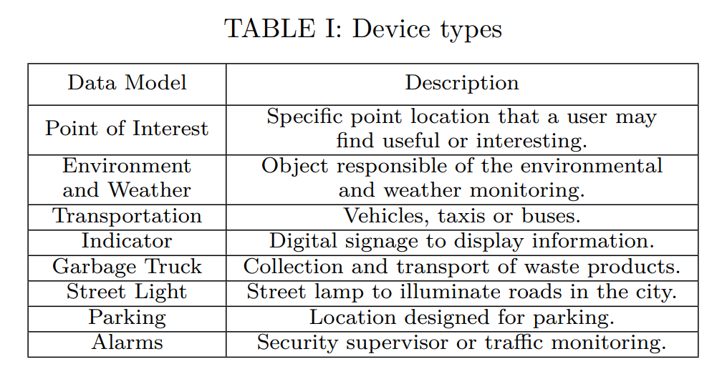

2) Devices social relationships: As mentioned early, we have used the devices’ social relationships to computer the socially-connected device communities. The dataset contains the following relationships that connect the devices:

* OOR (Ownership Object Relationship): type of social relationship to represent objects owned by the same user. About public static devices, objects will create a relation only if they are in the communication range of each other.
* POR (Parental Object Relationship): relation created among objects in the same type, model and brand, only if their distance is greater than a two threshold: 2 or 2.5 km.
* C-LOR (Co-Location Object Relationship): if static devices (public or private) and private mobile take contact more than 13 times (number of meetings), can create a co-location relation.
* SOR (Social Object Relationship): this relationship is based on three parameters, that are the number of meetings (N = 3), the meeting duration (TM = 30 minutes) and the interval between two consecutive meetings (TI = 6 hours). The relation is created between private mobile devices.
* SOR2 (Social Object Relationship): a variant of the SOR called SOR2 is created to connect the public mobile devices. In particular, the relation is between public mobile devices and users’ mobile objects. The parameters, as in the SOR, is set as follow: N = 3, TM = 1 minute and TI = 1 hour.
* SIoT: completely SIoT network is created with the combination of all relationships (all relations with an operation of disjunction OR).

## B. User interest dataset

In addition to the IoT devices dataset, we have also tested our proposed framework on Twitter dataset [?] to measure its ability to accurately compute the groups of interest and the effects of these groups on the accuracy of the service recommendation system. The dataset contains the text body of the tweets, and the interest of the users and the categories of these interests, the number of users, tweets and interest categories is shown in Table II. The first step of using the dataset is data sampling. As the dataset was raw and too large, we extracted two samples including all the different information of users. The first sample contains a set of users with their information including the timestamp of the recorded interests. The second sample contains the new relationships and interests of the same users and followers after a period. For the data processing step, we have created a social graph of users from the first sample, and clustered them on communities based on their relationships. The result groups will be used as an input for the classification algorithm that aims to create final group of interests. The recommendation algorithm will use these groups of interests to recommend services to devices that belong to the same social group. The recommendation algorithm will firstly extract a set of tags that meet the requirements of the recommendation for each group of interest. These tags are links of products and pages which will be recommended to the users within the same group. Practically, these tags are considered the preferences of devices that will be recommended to other devices that share social relationship as explained in the previous section of SIoT scenarios.

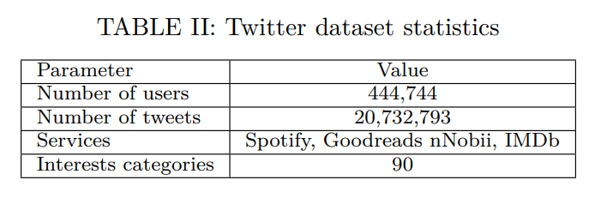

## C. Evaluation metrics

The performance of a recommendation system can be measured using different evaluation methods. Both Precision and Recall are suitable criteria to evaluate the recommendation system [?]. In the case of SIoT and IoT environments, precision is the number of the correctly recommended services offered to the devices out of the total number of the recommended services [?]. In the other hand, the recall is the number of the correctly recommended services out of the total relevant services that can be offered to the devices. In our case, metrics of the evaluation of the recommendation is the correlation between the final dataset, after applying the recommendation, with the second part of the dataset that is elaborated in Twitter social network. Service recommendation systems are evaluated according to their capability to accurately recognize the relevant services from the set of all available services. Four groups of decisions can be obtained from the confusion matrix that shows the correct and incorrect recommendations: (1) true positives (TP): the recommended relevant services according to the ground truth. (2) true negatives (TN): the ignored relevant services according to the ground truth (3) false positives (FP): the recommended irrelevant services according to the ground truth (4) false negatives (FN): the ignored irrelevant services according to the ground truth. We evaluated the proposed system and the baseline system based on the following metrics: Precision (P): is the ratio of relevant recommended services from the total services recommended by the system. It is computed using (4):

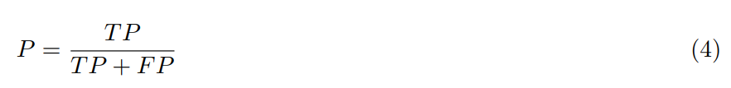

Recall (R): is the ratio of relevant recommended services from the total relevant services. It is computed using (5):

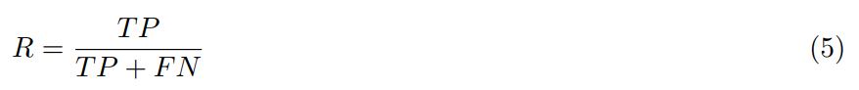

F-Measure: a combination of precision and recall in a single numerical value, it is also known as F-score, calculated using (6):

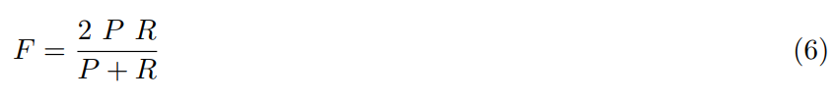

## D. Baselines

To test the effectiveness of our proposed framework, we have conducted the experiment on the two above mentioned datasets, and we have compared with the following baselines: Trust based approach (T-SIoT) [?]: Is a service recommendation for SIoT that is based on distributed collaborative filtering rating of friendship, social relationships as the filter. Location based approach (L-SIoT) [?]: Is a service recommendation for SIoT that is mainly based on the location of the devices and users. Trust and reputation approach (TRM-SIoT) [?]: Is a service recommendation for SIoT that combine trust and reputation in the recommendation process. To computer the recommended services, TRM-SIot uses a trust index and a reputation index. In our experiment the trust is computed using the friendship links among users, and the reputation index is computed using the priority of the devices, where the old static devices are more reputable than new and mobile devices. Mutual Context-aware Trustworthy Service Evaluation (MCTSE) [?]: is also a trust based recommendation framework for SIoT environment that uses the time and location of devices to establish trust among devices.

# VI. Results and discussions

The reason behind using these two datasets together is that we wanted to emphasize on the importance of incorporating the social relationship among devices on the one hand; on the other hand, we also wanted to prove our claim of how important it is to find the group of interest in enhancing the service recommendation in SIoT environment. To do that, we have applied our proposed algorithm (also other baselines’) to find the socially-connected user communities. After finding these communities, we used the map of these communities to twitter dataset users (using twitter followers’ relationships as our ground truth). in other words, we map the social relationship among users that was determined using the relationship between their devices to twitter following relationship. For example, a user X is mapped to user A in twitter dataset, user Y who is socially connected with use X is mapped to user B who is a friend of user A in twitter dataset. After mapping the users, we computed the group of interest and computed the precision/recall and f-measure. We varied the number of used devices (1000, 2000...10000) to determine the socially-connected communities, and observed the effects of that on the resulting precision/recall and f-measure. To give more credibility to the mapping process, we repeated the same process 100 times for each number of used devices (1000, 2000...10000) and the presented results in Fig.7, Fig.8 and Fig.9 are the average of these values. In our experiment, we used 10-fold validation, for each desired set of devices, 1000 for example, we have randomly (with location constrains) selected 10 sets of 1000 devices each, and we computed the socially-connected communities of each set, and the final results are the average of these ten times validations. As mention above, to evaluate the effectiveness of the proposed service recommendation framework, we have compared it in terms of precision, recall and F-Measure to the exiting SIoT service recommendation approaches (L-SIoT, T-SIoT, TR-SIoT and MCTSE). Fig.7, Fig.8 and Fig.9 show the performance of the proposed system when compared to the baselines in terms of precision, recall and F-Measure respectively. From Fig.7 we can clearly observe that the proposed system achieves the best precision value compared to the other baselines, that is because the proposed framework incorporates many social relationships that connect the device to form the socially-connected device communities, unlike other baseline that focus on single factor (location relationship in the case of L-SIoT, trust relationship in the case of T-SIoT). Hence the proposed framework can recommend relevant services of all types of social relationships that connect the devices. From Fig.7 we can also observe that TR-SIoT has the better precision values among other baselines, that is because it incorporates the trust index as well as the reputation index of network devices. Lastly, we can observe that all the systems (including the proposed framework) precision decrease with the increase of the number of devices, however, the proposed framework’s precision decrease is still relatively low (0.815 precision value in 10000 devices environment, which is 95% of the precision value in 1000 devices environment). Which is not the case with the other baselines (78.66% for L-SIoT, 82.69% for T-SIoT, 86.25% for TR-SIoT and 86.07% for MCTSE).

|  |
| --- |
| Fig. 7: Precision-wise systems comparison |
| Fig. 8: Recall-wise system comparison |
| Fig. 9: F-Measure-wise system comparison |

Fig.8 shows the recall values of the proposed framework and other baselines in different device density environment, from 1000 devices to 10000 devices. We can observe that the proposed framework has the best recall values in all device density environments compared to all other baselines. As with the precision, T-SIoT still have the worst recall values compare to other baselines, that is because this scheme is based only on the location of the devices to recommend services, regardless of the user friendship, trust and common interest, which could lead to more irrelevant services. The overall F-measure of the proposed system and other baselines is presented in Fig.9, which also shows the superiority of the proposed framework in terms of F-Measure. From Fig.7, Fig.8 and Fig.9 we can clearly observe that the proposed framework has the upper hand in terms of precision, recall and F-measure respectively. However, this superiority comes at the cost of the relatively high computational cost of the proposed framework compared to the other baselines, We can observe that the proposed system has a relatively higher computational cost in all device density environments. This additional computational cost is due to community detection algorithm, and group of interest detection schemes that our proposed framework has to perform before recommending relevant services. That being said, the additional computational cost is not the main concern in the modern IoT system, that is because the computational can be done within the distributed devices themselves [?], and not on a centralized server that could be overloaded. Therefore, we can say that the additional computational cost is not drawback in our proposed framework. Table III shows the number of groups of interests as well as the number of recommended services to 10 lists of users extracted from the first portion of the chronologically ordered twitter dataset. These lists ranges from 100 to 5000 users. A second portion with the same size is used to verify the quality of the recommendations. We created the list of groups of interests and extracted the set of pertinent services based on the rank and common interests of users. After the clustering of groups, the users on each interest group receive the recommendations.

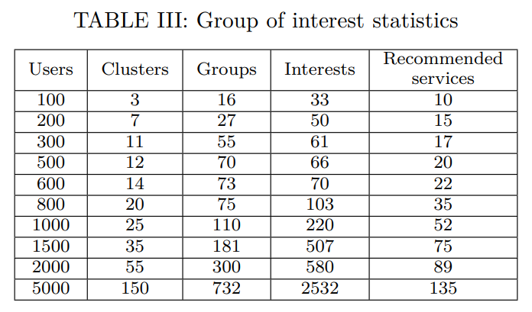

# VII. Conclusion and Future Work

In the SIoT network, every object needs to manage a large number of friends offering different services that match the device requirements but has different interest factors, trustworthiness values and availability. However, this process slows down the research of the desired services. The recommendation systems aim to retrieve the relevant services and suggest it to the users. They facilitate the process of information retrieval and improve the network navigability and service composition. In this paper, we proposed a service recommendation approach in SIoT to offer relevant services to devices, based on their relationships and interests. We presented firstly a background of different concepts of SIoT, devices’ relationships, and the related works that combine trust and recommendation systems in IoT. Moreover, we presented motivating examples that show the importance of service recommendations in SIoT environment. We found that clustering the SIoT devices, based on their relationships and the users’ interests, would create relevant service recommendations and offer services that fit the devices’ requirements. We formulated the recommendation process in IoT environment and extracted a formal similarity factors to match the services with the interested devices. Empirical evaluation of the proposed approach on a large dataset shows that the recommendation process on the groups of interest gave a high quality and improved the network navigability by providing relevant services to objects. However, the proposed framework could be improved in different aspects:

1. We have seen that the superiority of the proposed framework comes at the cost the additional computational cost required to determine the socially-connected device communities and group of interest. Therefore, reducing the computational cost of community detection algorithm is one of our future research direction.
2. One of the proposed social relationship is common location, some devices with high mobility velocity pose a challenge to find their socially-connected device community. Improving the proposed framework to offer personalized settings based on the type and characteristics of the studied device is a promising research directions.
3. Improving the proposed framework, by focusing more on the devices’ security and users’ privacy is one of our next research direction.

References:

[1] M. Hung, “Leading the IoT - Gartner Insights on How to Lead in a Connected World,” *Gartner*, pp. 1–29, 2017.

[2] S. Vongsingthong and S. Smanchat, “Internet of Things: A Review of Applications & Technologies,” *Suranaree J. Sci. Technol.*, vol. 21, no. 4, pp. 359–374, 2014.

[3] H. Ning, H. Liu, and others, “Cyber-physical-social based security architecture for future internet of things,” *Adv. Internet Things*, vol. 2, no. 01, p. 1, 2012.

[4] M. Nitti and L. Atzori, “What the SIoT needs: a new caching system or new friendship selection mechanism?,” in *2015 IEEE 2nd World Forum on Internet of Things (WF-IoT)*, 2015, pp. 424–429.

[5] L. Atzori, A. Iera, and G. Morabito, “Making things socialize in the Internet—Does it help our lives?,” in *Proceedings of ITU Kaleidoscope 2011: The Fully Networked Human?-Innovations for Future Networks and Services (K-2011)*, 2011, pp. 1–8.

[6] A. P. Fiske and N. Haslam, “The Four Basic Social Bonds: Structures for Coordinating Interaction.,” 2005.

[7] M. Nitti, R. Girau, and L. Atzori, “Trustworthiness management in the social internet of things,” *IEEE Trans. Knowl. Data Eng.*, vol. 26, no. 5, pp. 1253–1266, 2013.

[8] I. Mashal, O. Alsaryrah, and T. Y. Chung, “Performance evaluation of recommendation algorithms on Internet of Things services,” *Phys. A Stat. Mech. its Appl.*, vol. 451, pp. 646–656, 2016.

[9] L. Guo, J. Liang, Y. Zhu, Y. Luo, L. Sun, and X. Zheng, “Collaborative filtering recommendation based on trust and emotion,” *J. Intell. Inf. Syst.*, vol. 53, no. 1, pp. 113–135, 2019.

[10] C. Li, J. Tang, H. Tang, and Y. Luo, “Collaborative cache allocation and task scheduling for data-intensive applications in edge computing environment,” *Futur. Gener. Comput. Syst.*, vol. 95, pp. 249–264, 2019.

[11] P. B.Thorat, R. M. Goudar, and S. Barve, “Survey on Collaborative Filtering, Content-based Filtering and Hybrid Recommendation System,” *Int. J. Comput. Appl.*, vol. 110, no. 4, pp. 31–36, 2015.